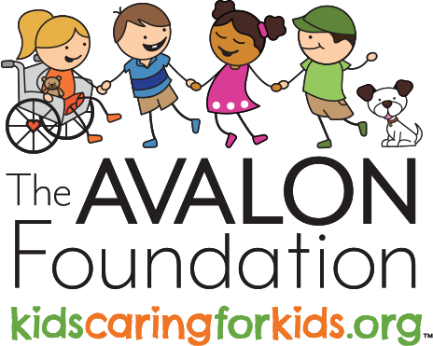
Deborah Ayres
President

(419) 290 - 4332
debayres@kidscaringforkids.org

The Avalon Foundation

3328 Brantford Road
Ottawa Hills, Ohio 43606
www.kidscaringforkids.org

Social Media

@theavalonfoundation @kcfktaf @theavalonfoundation @theavalonfoundation

Dear Parents,

We are pleased to inform you that we have identified your child as a strong candidate for a local youth leadership program with The Avalon Foundation. We feel that your child would be a wonderful fit with the opportunities for growth and development that this program offers to local youth. There are several levels that your child and or family can engage with through this organization.

The Avalon Foundation is an organization that promotes and teaches youth leadership through service by offering peer support to kids receiving life-altering treatment for rare diseases. The Avalon Foundation is dedicated to building youth leaders in the Toledo area while helping families all over the United States.

Each engagement with The Avalon Foundation allows for opportunities for growth and development of leadership skills with like-minded kids as well as enhancing care and compassion for others.

We invite you to read more about the leadership opportunities and explore more about The Avalon Foundation and its #KC4K Youth Leadership Program through the QR code below.

We are excited that your child has been nominated as a future leader with The Avalon Foundation. Please expect a call from a #KC4K Program Team Member to discuss this wonderful leadership opportunity.

If you have any questions about this nomination, please contact me at
{Your Phone Number XXX-XXX-XXXX}.

Warm Wishes,

{Your Name}
{Your Title}
{Your School Name}

