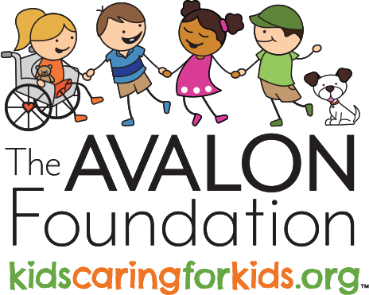
Deborah Ayers
President

(419) 290 - 4332
debayers@kidscaringforkids.org

The Avalon Foundation

P.O. Box 9021
Toledo, OH 43697 www.kidscaringforkids.org

Social Media

@theavalonfoundation @kcfktaf @theavalonfoundation @theavalonfoundation

Newsletter Insert Content
Please use the content below to include information in your school newsletter or email.

The Avalon Foundation connects kids to other kids who are battling rare diseases to create a network of understanding through ambassadorship and provide support programs for successful treatment.

Youth who volunteer will develop leadership skills they’ll use throughout their lives, as well as a strong sense of personal fulfillment. People who feel like they have a purpose and are making a positive impact on the world tend to have better emotional and physical health.

Our goal is to encourage more kids to volunteer their time, offer peer support to kids going through treatment for rare disease and, ultimately, help kids succeed.

Learn more by scanning the QR code below.

